Service Lifecycle
- Every service in Azure follows its own service lifecycle
- Public preview is a ‘beta’ stage of the service available to general public use
- Features can also be in preview stages
- Designed for testing, not production solutions
- General availability is a ‘production’ release of the service
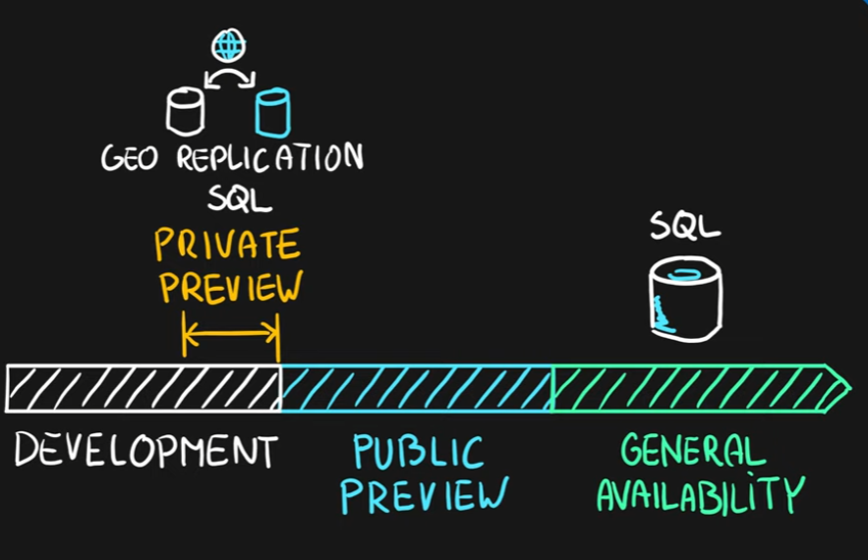

Public Preview Key Info
- No SLA
- Some services have no support coverage
- Limited region availability
- Limited functionality
- Pricing changes
- Direction changes
- Azure Portal Previews (https://preview.portal.azure.com)

